Jake Blosveren
Socrates: the Man of Wisdom
1 Nov. 2016

Our good friend and scholar, Socrates, age 71 died today in 399 BC. As many know, Socrates was born in 470 BC in Alopeke, Greece. In Alopeke, growing up, Socrates belonged to the tribe called Antiochis. Because he wasn't from a very wealthy or noble family so he only received a basic Greek education. Socrates mother was named Phaenarete. Phaenarete was a midwife and specialized in having babies. Socrates father, Sophroniscus, was a stonemason. His father would carve and sculpt stone and marble statues and other pieces of art. Socrates is perhaps seen, by many of us here today, as the most influential philosopher in Greece, but before he devoted his life to learning and becoming was this great philosopher, he was first started working with his father as a stonemason. He learned from his father at a young age and became very skilled. One of his statues of “Three Graces” was showcased near the Acropolis up until the 2nd century AD. Socrates also played his role in defending his homeland. He was part of Greece’s military as a hoplite. A hoplite is a Greek soldier usually only equipped with a spear and shield. He was a hoplite during the Peloponnesian war which was fought by Athens and its empire against the Peloponnesian League that was led by Sparta. “He participated in three military campaigns during the Peloponnesian War, at Delium, Amphipolis, and Potidaea, where he saved the life of Alcibiades, a popular Athenian general.” Socrates was known for having a lot of courage in battle and having no fear. These experiences at war is a part of what made his who he was and created an impact on his personality that stayed with him throughout his life (Schneider, 2012).
His looks did not match his appearance. Socrates’physical appearance was not that of a typical Athenian soldier. He was in fact Short and stocky. This may have also influenced his philosophy because Socrates always “emphasized the importance of the mind over the relative unimportance of the human body” (Schneider, 2012). Who knows if he would have had these thoughts if he had a better appearance.
He was a good husband and father. His wife Xantippe, who is everyone knows for having an “undesirable temperament” (Satoris, 2005). But he didn’t let this bother him. Maybe because she was much younger than he was. Some say that she up to 40 year younger than him. Socrates and Xantippe had three sons named, Lamprocles, Sophroniscus and Menexenus. Even though Socrates is a great philosopher, he is nowhere near a great father. Coming from Socrates himself, he would say that he cared more about teaching and spreading his wisdom to the people of Athen than he did for his own three sons (Schneider, 2012).
Those who knew him were lucky to have had him in their lives. In Socrates older years he had became very influential and famous in Greece. He tried to avoid being involved in politics but he couldn't seem to stay out of it. During the end of the Peloponnesian War. In 406 B.C. Socrate assembled an argument which eventually lead to a few of Greece’s top generals to executed for leaving Dead Athenian soldiers bodies from Sparta battle grounds. Three years after this, “When a tyrannical Athenian government ordered Socrates to participate in the arrest and execution of Leon of Salamis, he refused” (Waterfield, 2009). This act of disobedience was referenced in Martin Luther King’s “Letter from a Birmingham Jail” The tyrant leaders were taken over and ridden of their power before they could punish Socrates. In 399 he was tried for “failing to honor the Athenian gods and for corrupting the young” (Mackenzie, 2014). Even though he put up a good defense during his trial, he was sentenced to be executed. His close friends and family tried to convince him to escape from Athens, but he refused. On the day of his execution he drank a cup of poison given to him. He walked around until his legs gave out and laid down, surrounded by his friends, and waited for the poison to reach his heart and kill him (Sataris, 2014). Obviously, he was a good man who left us too soon. It is too bad that he let his stubbornness be his end.
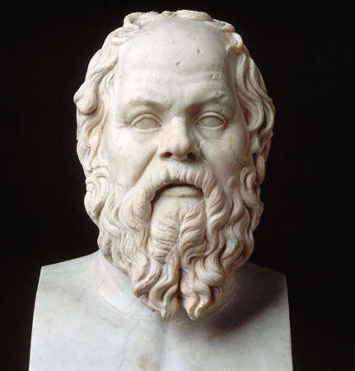

References
Satris, S. (2015). Socrates. Salem Press Biographical Encyclopedia, Research Starters,
EBSCOhost. Retrieved 1 Nov. 2016.
Waterfield, R. (2009). The Historical Socrates. History Today, 59(1), 24. MasterFILE Premier,
EBSCOhost. Retrieved 1 Nov. 2016.
Schneider, J. (2012). Socrates and the madness of method. Phi Delta Kappan, 94(1), 26.
MasterFILE Premier, EBSCOhost. Retrieved 1. Nov. 2016. .
Mackenzie, J. (2014). Peers on Socrates and Plato. Educational Philosophy & Theory, 46(7),
764-777. doi:10.1080/00131857.2013.794690. Retrieved 1 Nov. 2016.

